Gases

- A principle difference between a liquid and a gas is that when a liquid is under pressure, its volume ,

increases | decreases | doesn't change noticeably

and its density .

increases | decreases | doesn't change noticeably

- When a gas is under pressure, its volume ,

increases | decreases | doesn't change noticeably

and its density ,

increases | decreases | doesn't change noticeably
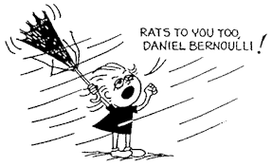
Refer to the following information for the next question.

The following cartoon is more humorous to physics types than to non-physics types.
- What physics has occurred?

Refer to the following information for the next question.

The sketch below shows the launching of a weather balloon at sea level. Discuss with your partner and then describe what the same weather balloon would look like when it is high in the atmosphere.

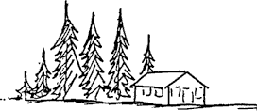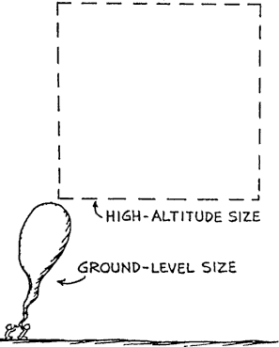

a. That is, what would be different about its size and why?
- In general, a hydrogen-filled balloon that weighs 20 N must displace N of air in order to float in air.

- If it displaces less than N it will be buoyed up with less than N and sink.
- If it displaces more than N it will be buoyed up with more than N and move upward.

- A birthday candle burns in a deep drinking glass. When the glass is whirled around in a circular path, say held at arm's length while one is spinning like an ice skater, which way does the candle flame point? Explain.

6.
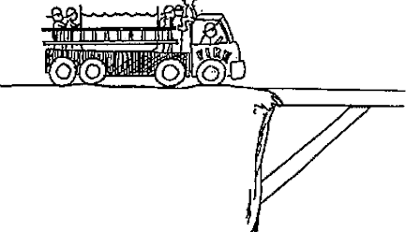
A fire truck carrying a load of fire fighters and a large tank of water is about to cross a bridge that may not support the load. The chief suggests that some of the people aboard get into the tank so the load will be less. Is this a good idea or a poor idea? Explain.

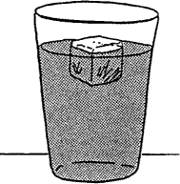
- REVIEW
An astronaut on earth notes that in her soft drink an ice cube floats with 9/10 its volume submerged. If she were instead in a lunar module parked on the moon, the ice in the same soft drink would float with .

  - less than 9/10 submerged.
  - 9/10 submerged.
  - more than 9/10 submerged

8/ REVIEW
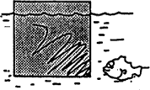

The density of the block of wood floating in water is .

- greater than the density of water
- equal to the density of water
- less than half that of water
- more than half the density of water
- .. . not enough information is given
- If you release a ball inside a freely-falling elevator it stays in front of you instead of "falling to the floor" because you, the ball, and the elevator are all accelerating downward at the same acceleration, g. If you similarly release a helium-filled balloon, the balloon will .

  - also stay in front of you
  - press against the ceiling
  - press against the floor

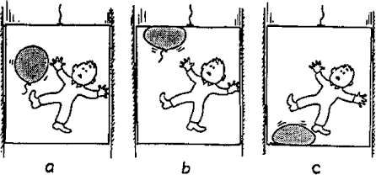

- Consider a flexible plastic bottle containing both air and water immersed neck down in an open dish of water. The water level in the bottle will .
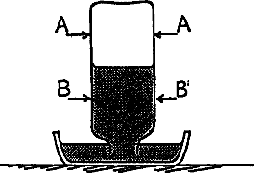

- fall if pinched at A but rise if pinched at B
- fall if pinched at A or at B
- fall if pinched at A but stay where it is if pinched at B
- rise if pinched at A but stay where it is if pinched at B
- stay where' it is if pinched at A or at B
- Consider a Ping-Pong ban floating in a glass of water that is enclosed in an airtight chamber.
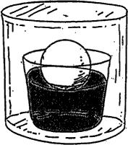

When air pressure is increased in the chamber, does the ball float lower, higher, or as before? Explain

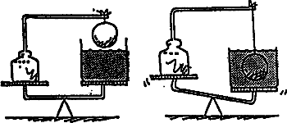
- The weight of the stand and suspended solid iron ball is equal to the weight of the container of water as shown above. When the ball is lowered into the water, the balance is upset.

The amount of weight that must be added to the left side to restore balance, compared to the weight of water displaced by the ball, would be .

  - half
  - the same
  - twice
  - more than twice

